

Digital Scheme Book
Scheme Name: Maynard Co-operative Housing Association managed by PA Housing
Housing Management Officer: Krishan Mistry

Neighbourhood: Highfields Leicester LE2 post codes - See map below
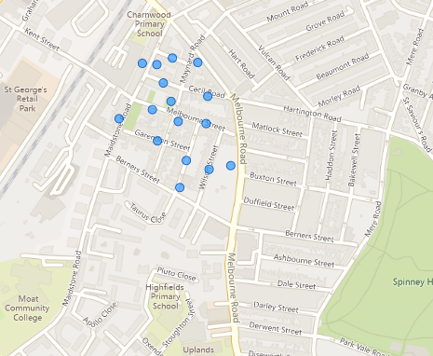

Date last updated:
10 December 2024

Contents

Estate Photos - Exterior 2
Estate Photos – Surgery/Office 4
Estate Photos – Surgery / Office 5
Estate Photos – Scheme 2 Melbourne Street 6
Estate Photos - Scheme 10 Melbourne Street 7
Estate Photos - Scheme 19 Melbourne Street 8
Estate Photos – Scheme 50 Melbourne Street 9
Estate Photos – Scheme 6 Berners Street 10
Estate Photos - Scheme 16 Berners Street 11
Estate Photos - Scheme 15 Garendon Street 12
Estate Photos - Scheme 4 Melbourne Road 13
Estate Photos – Highfields Community Centre 14
Estate Details 15
Legal/Ownership 15
Managing Agent Company Information 15
Residents Association & Neighbourhood Champions 15
Local Authority Details & Contacts 15
Local Authority Specific Contacts 16
Site Office 16

Estate Photos - Exterior – Council owned play area
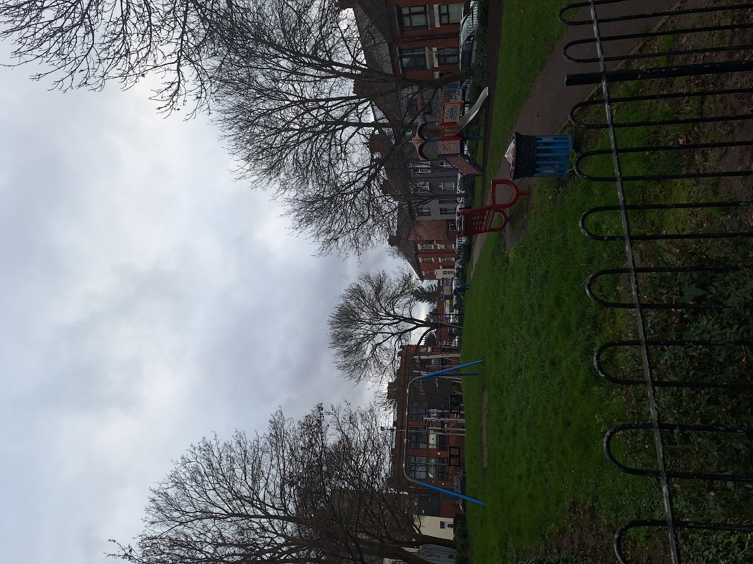

Estate Photos – Surgery/Office 34 Cecil Road

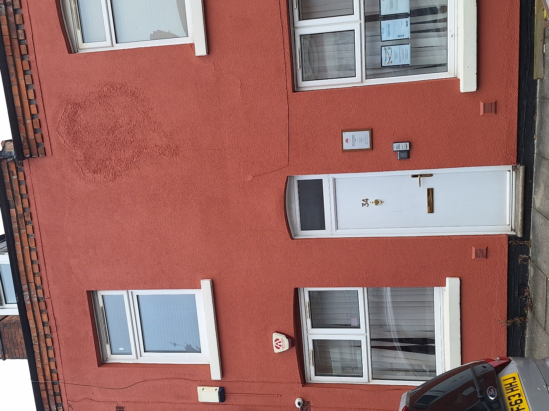

Estate Photos – Surgery / Office

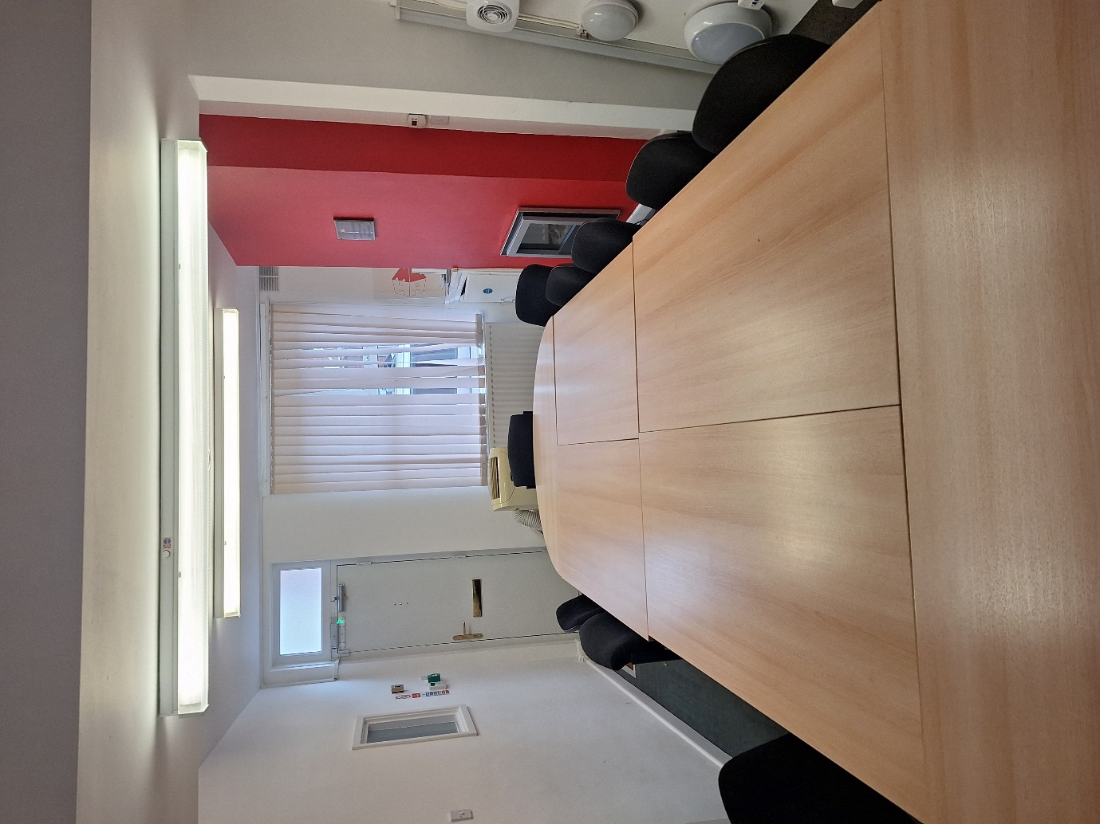

Estate Photos – Scheme 2 Melbourne Street

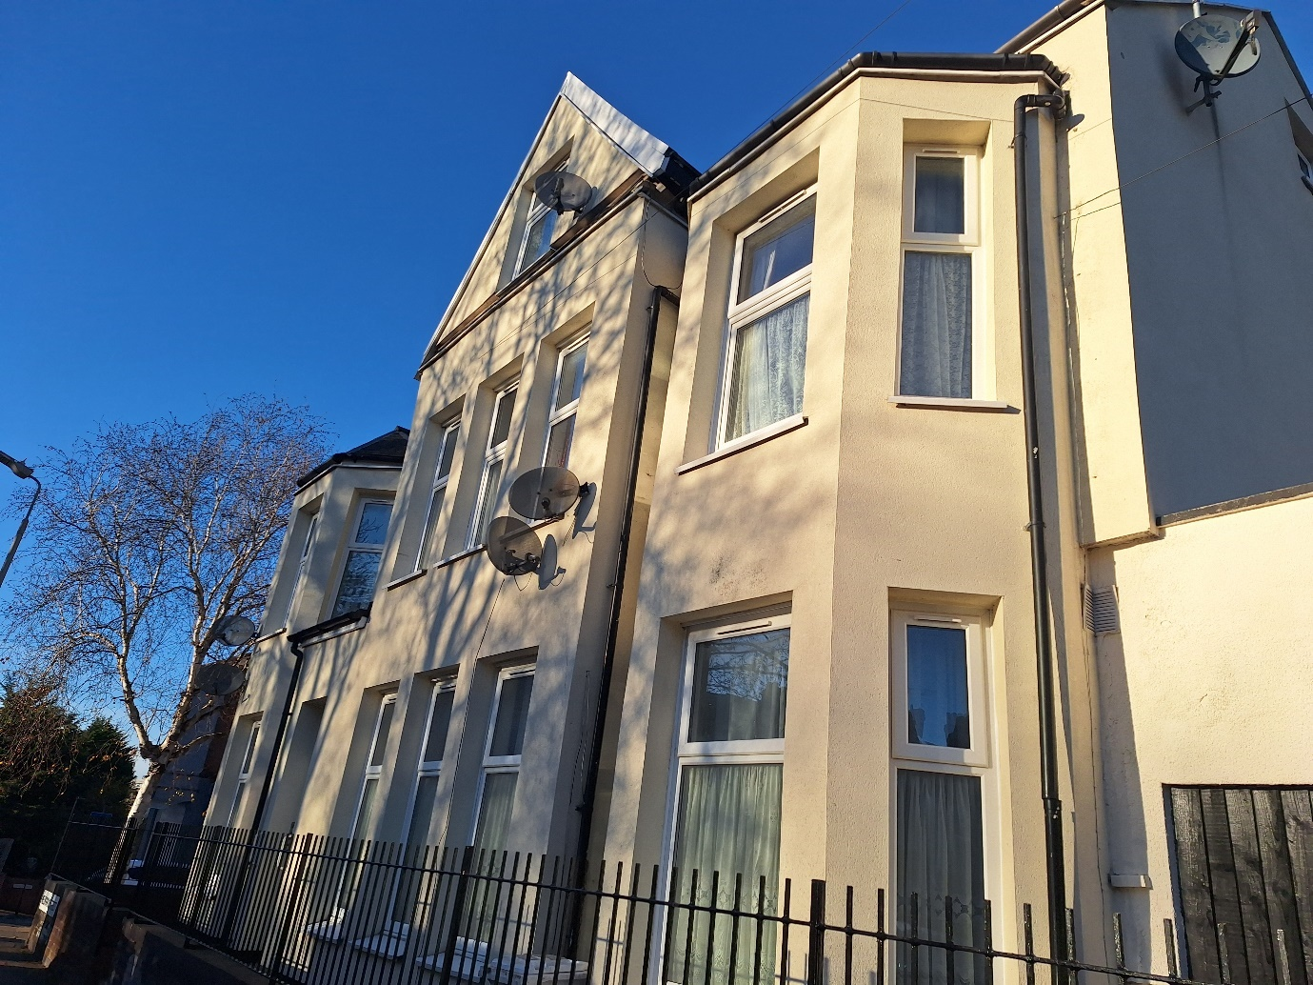

Estate Photos - Scheme 10 Melbourne Street

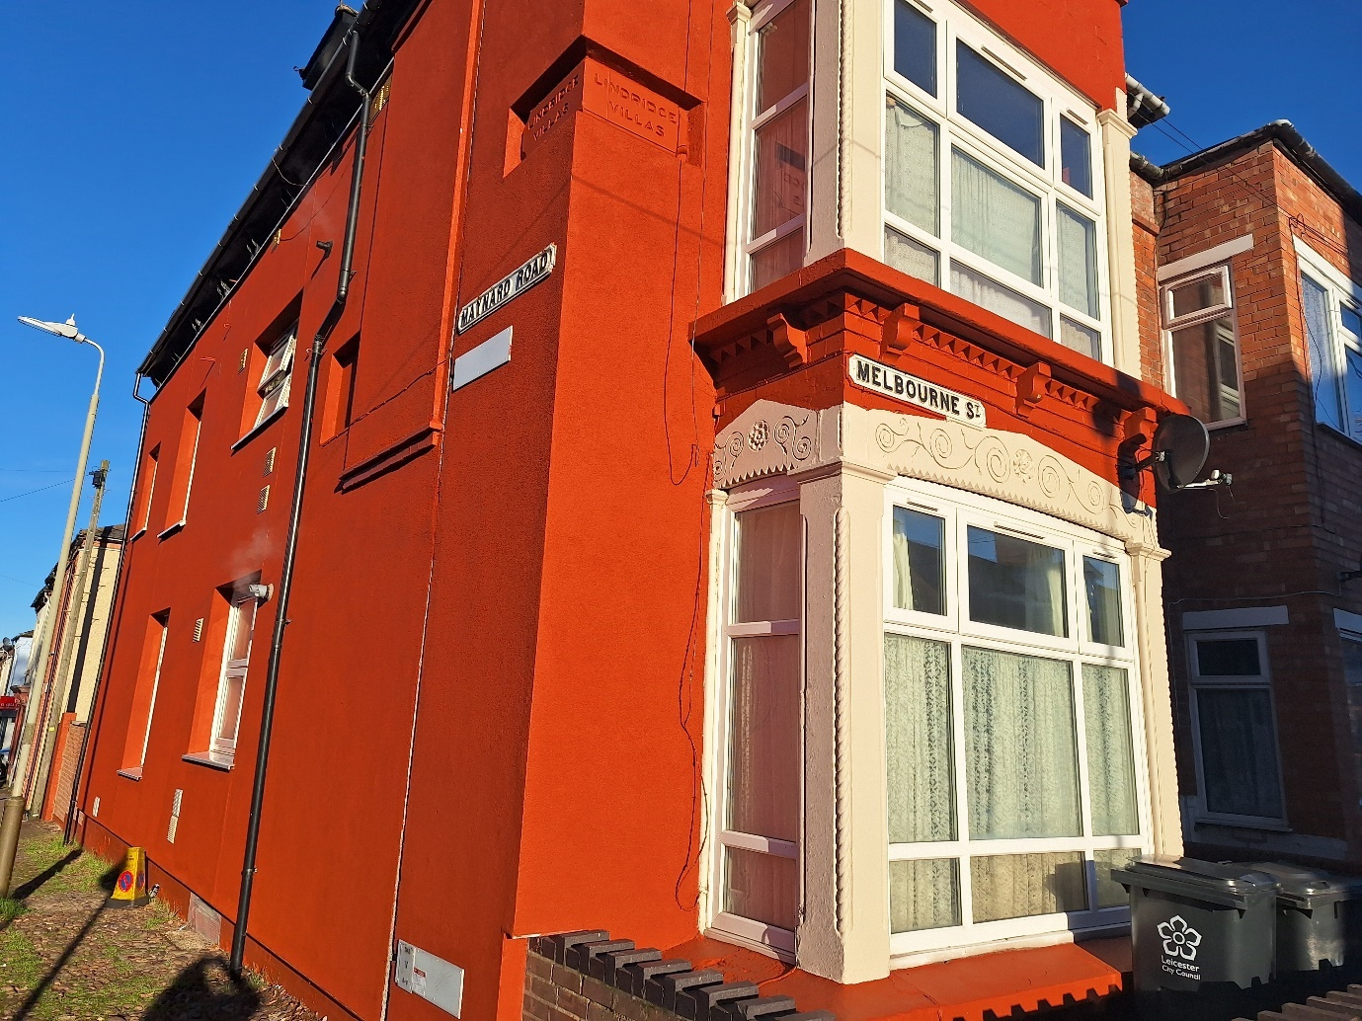

Estate Photos - Scheme 19 Melbourne Street

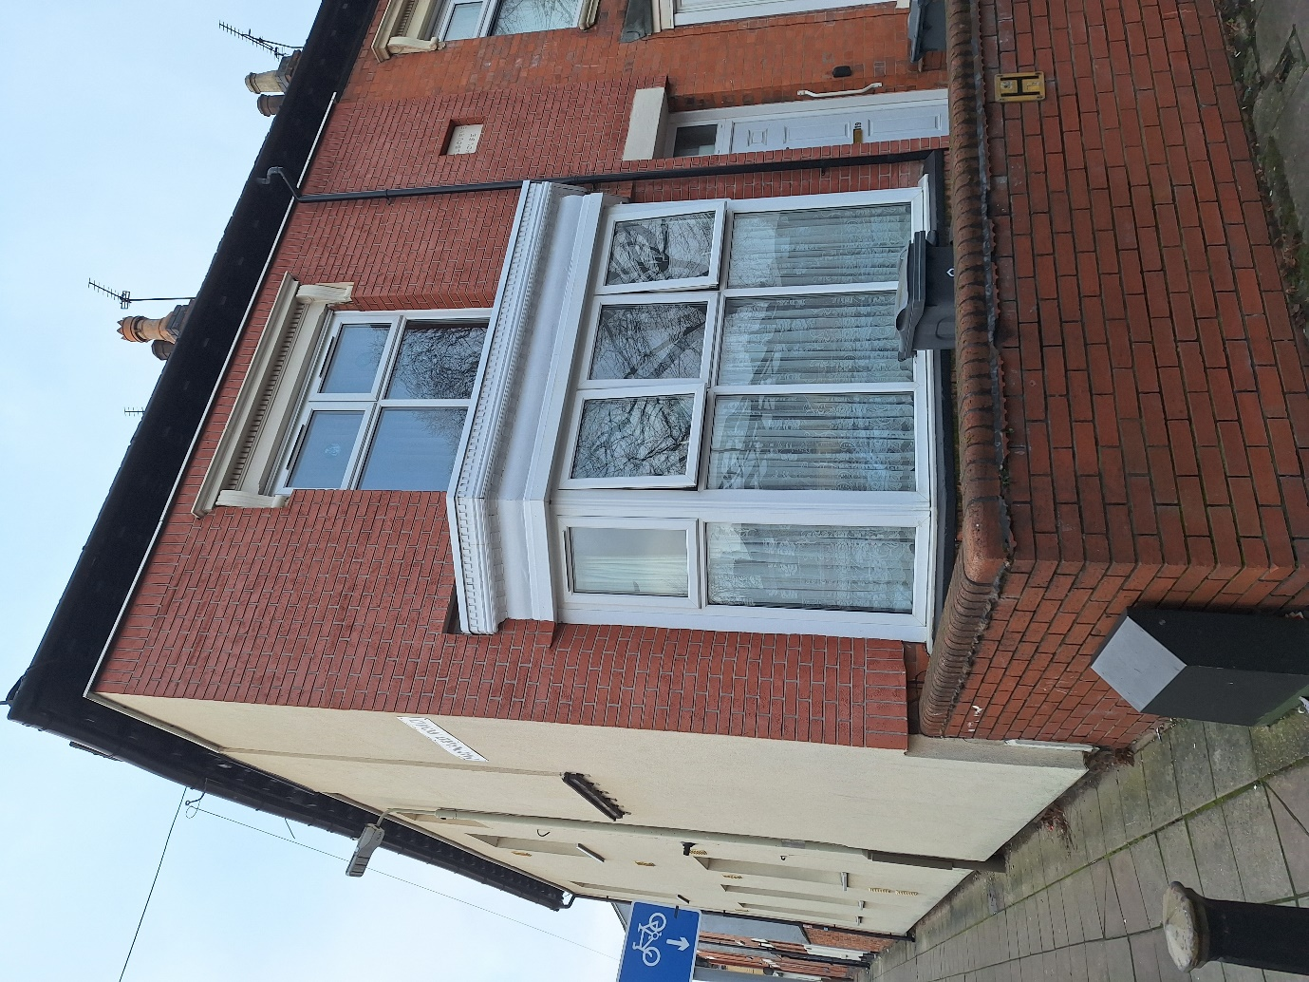

Estate Photos – Scheme 50 Melbourne Street

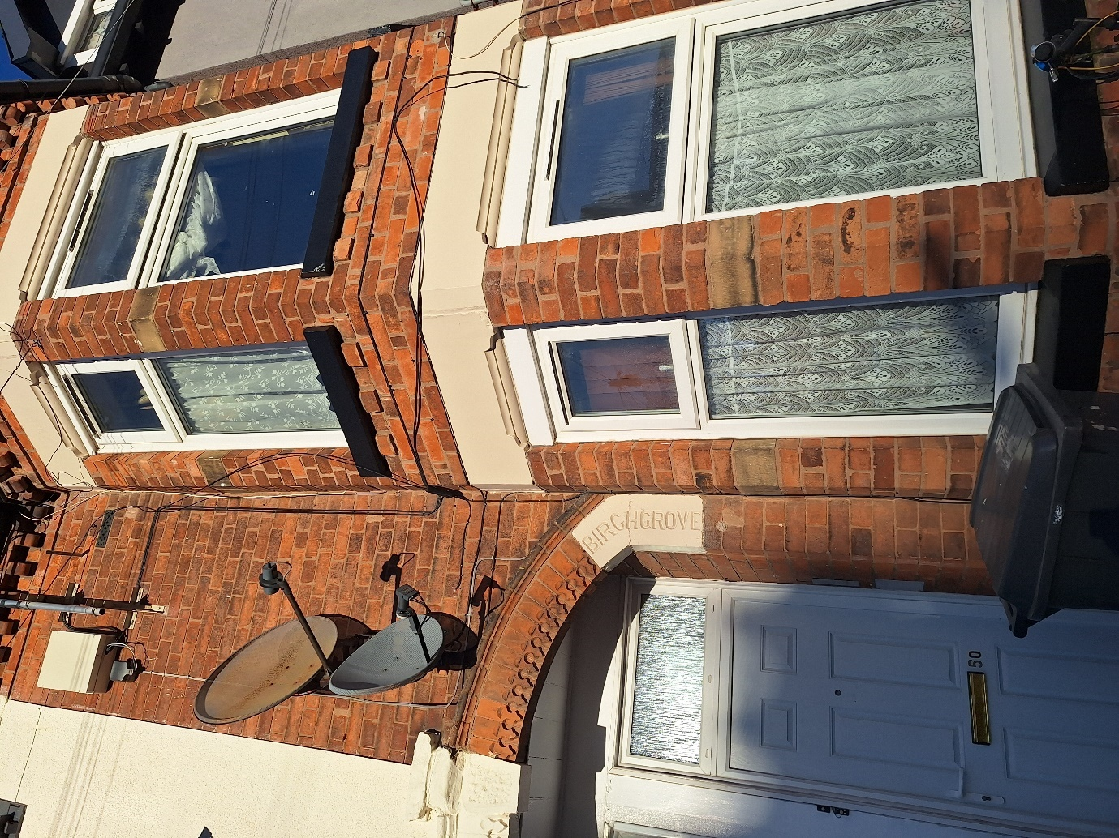

Estate Photos – Scheme 6 Berners Street

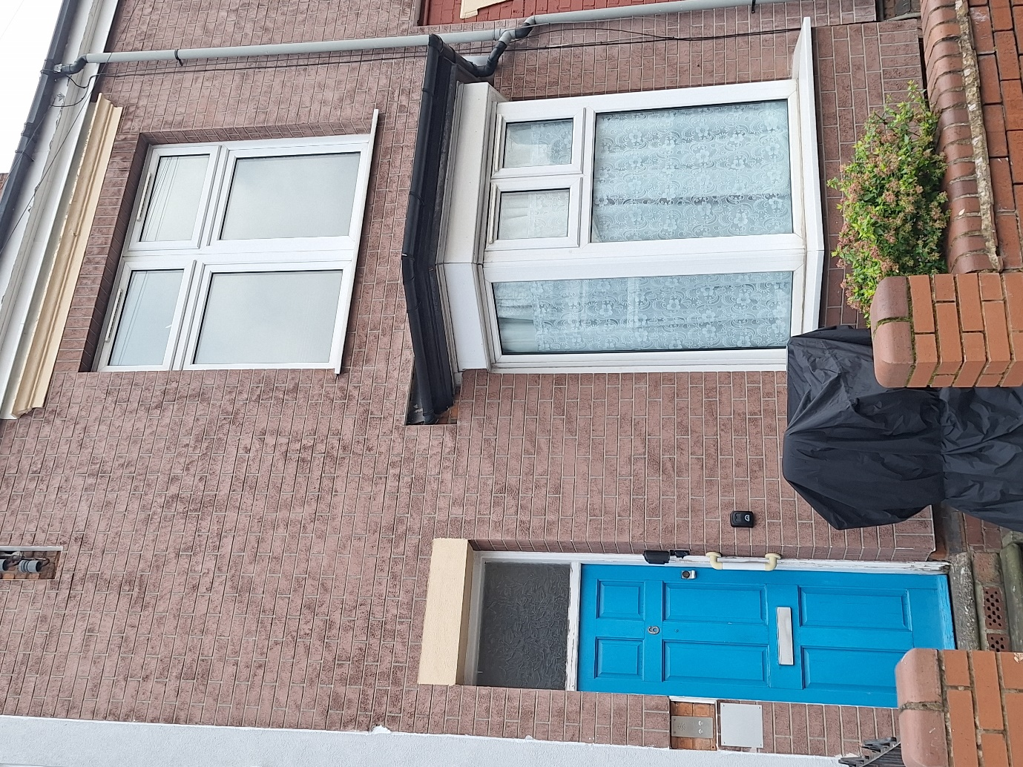

Estate Photos - Scheme 16 Berners Street

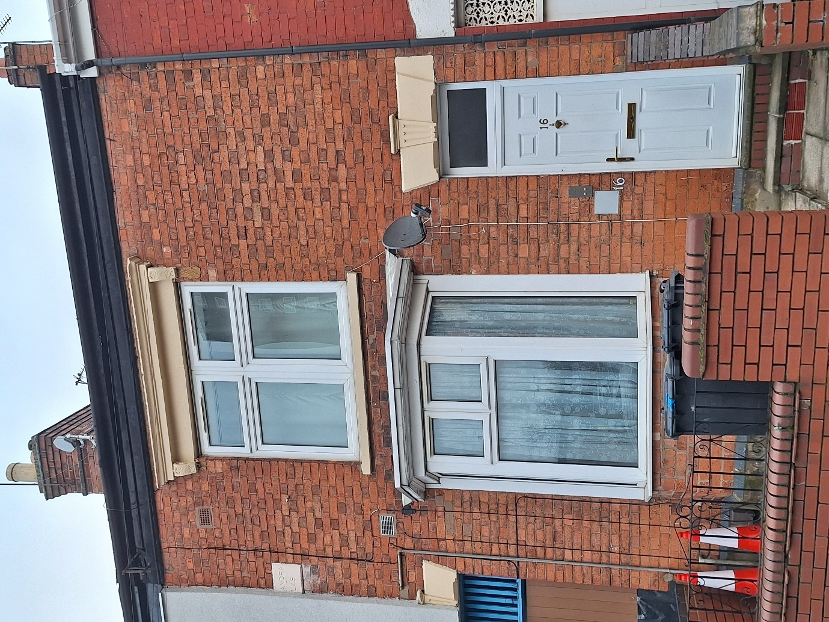

Estate Photos - Scheme 15 Garendon Street

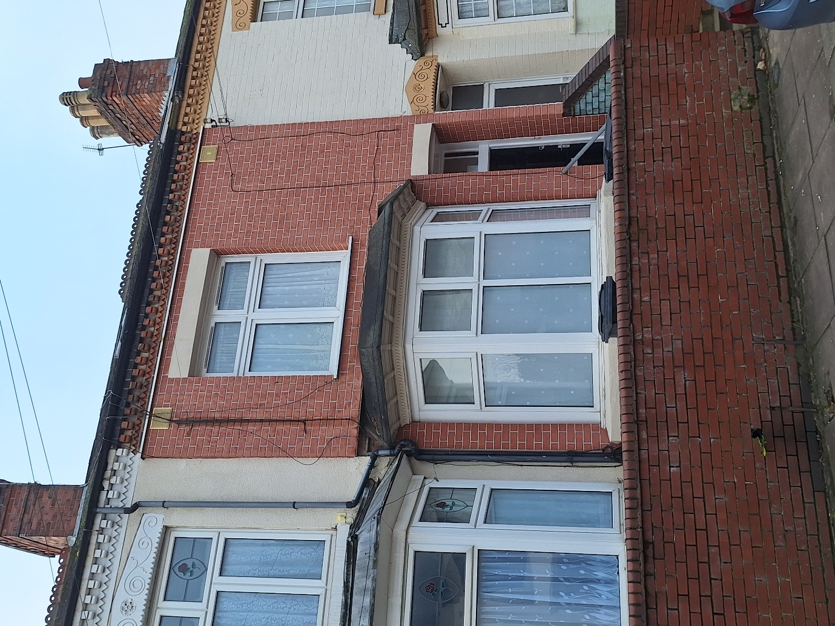

Estate Photos - Scheme 4 Melbourne Road

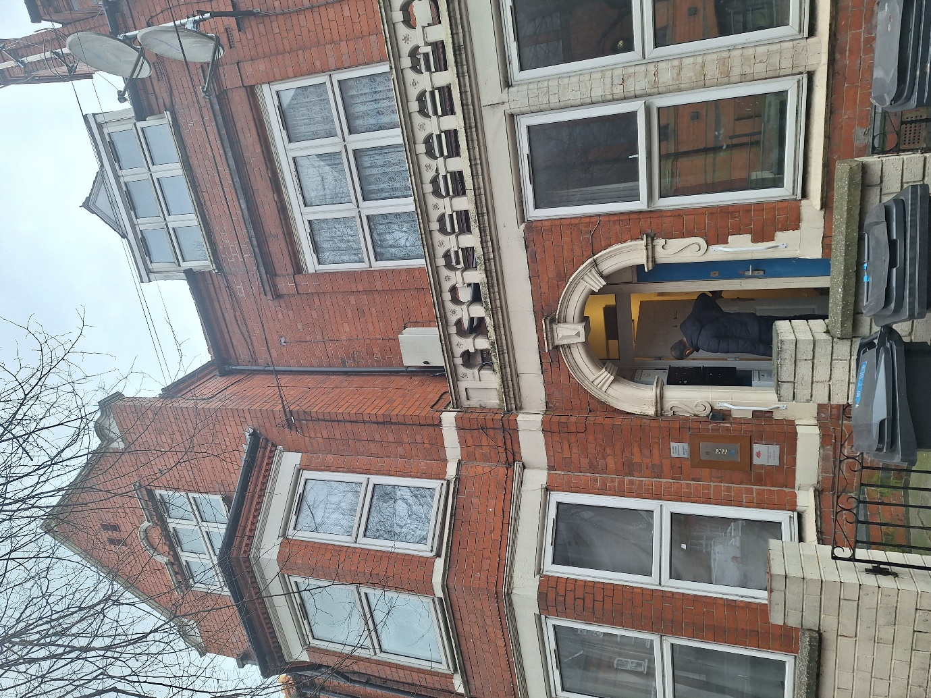

Estate Photos – Highfields Community Centre

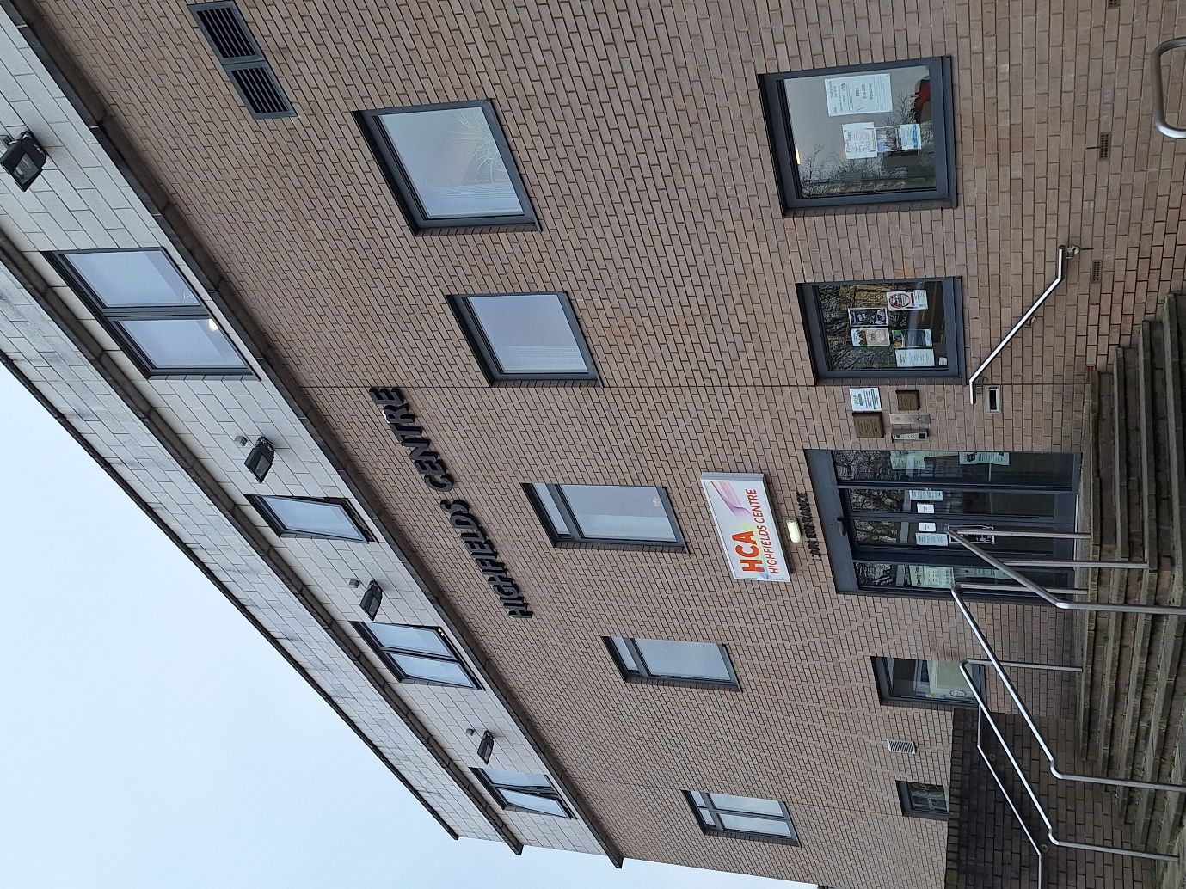

Estate Details
Housing Management Officer | Krishan Mistry
Email Address: | Krishan.mistry@pahousing.co.uk
Phone Number: | 01162576800 / 07514664003
Estate Name: | Maynard Cooperative Housing Association
Full Address: | Homes in the LE2 Highfields area of Leicester
Estate Reference Number:
Number of Units: | 118
Number of General needs units: | 118 of which 21 are flats and 97 houses
Number of shared Owners: | 0
Number of Leaseholders: | 0

Legal/Ownership
FreeHolder: | All owned by Maynard Cooperative Housing Association

Managing Agent Company Information
Managing Agent Company Name: | PA Housing
Contact: | 3 Bede Island Road Leicester LE2 7EA
Email Address: | coops@pahousing.co.uk
Phone Number: | 01162576800
Responsibility of Managing Agent: | All services to Maynard Cooperative

Residents Association & Neighbourhood Champions
Residents Association: | Maynard Committee
Neighbourhood Champions: | N/A
Email Address: | coops@pahousing.co.uk
Phone Number: | 01162576800

Local Authority Details & Contacts
Local Authority: | Leicester City Council
Local Councillors: | Councillor Mohammed Dawood ( 07800 907313) and Councillor Hanif Aqbany (0116 454 5895
Email Address: | customer.services@leicester.gov.uk;
Phone Number: | 01164541000 (Mon - Fri 10.30am - 3.30pm)

Local Authority Specific Contacts

Safer Neighbourhoods Team: | Spinney Hills | Your area | Leicestershire Police | Leicestershire Police
Safeguarding: | Leicester City Council - 0116 454 1004, Adult or Leicestershire Police
Mental Health: | Mental Health Central Access Point on 0808 800 3302. Provided by Leicestershire Partnership NHS Trust.
PCSO: | Spinney Hills | Your area | Leicestershire Police | Leicestershire Police

Site Office
Scheme Office: | 34 Cecil Road, Leicester LE2 0AD
Hours of Scheme | Surgery every Tuesday 2-4.30pm
Contact: | Krishan Mistry
Email Address: | coops@pahousing.co.uk
Phone Number: | 0116 2107359

Scheme info for 8 block of flats owned by Maynard Cooperative below
Description | 2 Melbourne street Leicester, Leicestershire, LE2 0AR | 10 Melbourne Street, Leicester, Leicestershire, LE2 0AS | 19 Melbourne street, Leicester, Leicestershire, LE2 0AR | 50 Melbourne Street Leicester, Leicestershire, LE2 0AS | 6 Berners Street, Leicester, Leicestershire, LE2 0AF | 16 Berners Street, Leicester, Leicestershire, LE2 0AF | 15 Garendon Street, Leicester, Leicestershire, LE2 0AH | 4 Melbourne Road, Leicester, Leicestershire, LE2 0DR
Date scheme sheet updated | 10/12/24 | 11/12/2024 | 12/12/2024 | 12/12/2024 | 12/12/2024 | 12/12/2024 | 12/12/2024 | 12/12/2024
General
Scheme Name | 2 Melbourne Street | 10 Melbourne Street | 19 Melbourne Street | 50 Melbourne  Street | 6 Berners  Street | 16 Berners Street | 15 Garendon Street | 4 Melbourne Road
Scheme Northgate Code | Melbou | Melboublk1 | Melboublk2 | Melboublk6 | Berner | Bernerblk1 | garenblk1 | Melboublk5
Number of properties | 5 | 3 | 1 | 2 | 2 | 2 | 2 | 4
Number of Blocks | 1 | 1 | 1 | 1 | 1 | 1 | 1 | 1
Tenure Types of Properties and details | Coop Contractual | Coop Contractual | Coop Contractual | Coop Contractual | Coop Contractual | Coop Contractual | Coop Contractual | Coop Contractual
Is there an office onsite | No | No | No | No | No | No | No | No
Cleaning/Gardening
Cleaning contractor | Max cleaners, 07967975181 | Max cleaners, 07967975181 | Max cleaners, 07967975181 | Max cleaners, 07967975181 | Max cleaners, 07967975181 | Max cleaners, 07967975181 | Max cleaners, 07967975181 | Max cleaners, 07967975181
Frequency | Once a month | Once a month | Quarterly | Quarterly | Quarterly | Quarterly | Quarterly | Once a month
Gardening contractor | Max cleaners, 07967975181 | Max cleaners, 07967975181 | Max cleaners, 07967975181 | N/A | N/A | N/A | N/A | Max cleaners, 07967975181
Frequency | quarterly | quarterly | quarterly | N/A | N/A | N/A | N/A | Quarterly
Access
Is there fob access? | Yes | No | No | No | No | No | No | Yes
Is there a key pad? | No | No | No | No | No | No | No | No
Are there keys? | No | Yes | Yes | Yes | Yes | Yes | Yes | No
If so what type of lock? | N/A | Yale lock | Yale lock | Yale Lock | Yale Lock | Yale Lock | Yale Lock | N/A
How do customers access the building | Intercom / fob | Key or intercom | Intercom or key | Intercom or key | Intercom or key | Intercom or key | Intercom or key | Intercom / fob
How does a customer obtain a new fob or key | Contact HMO | Contact HMO | Contact HMO | Contact HMO | Contact HMO | Contact HMO | Contact HMO | Contact HMO
Who provides the fob or key | JCP Contractor (under review) | Contact HMO | Contact HMO | Contact HMO | Contact HMO | Contact HMO | Contact HMO | JCP Contractor (under review)
How many keys/fobs can a customer have | 1 | 1 | 1 | 1 | 1 | 1 | 1 | 1
Is there an onsite presence to arrange lock change/repair to communal access | No | No | No | No | No | No | No | No
Do PA have a key/fob for access | Yes | Yes | Yes | Yes | Yes | Yes | Yes | Yes
Where is the key/fob in PA | Cecil road office | Cecil road office | Cecil road Office | Cecil road Office | Cecil road Office | Cecil road Office | Cecil road office | Cecil road office
Is there a key safe (if so what is the code) | Yes - 1988 | Yes - 1988 | Yes - 1988 | Yes - 1988 | Yes- 1988 | Yes - 1988 | Yes - 1988 | Yes - 1988
CCTV
Is there CCTV? | No | No | No | No | No | No | No | Yes
Who should be contacted if there is a fault? | N/A | N/A | N/A | N/A | N/A | N/A | N/A | Assured Alarms contact details Nasser 07802488944
How is footage obtained? | N/A | N/A | N/A | N/A | N/A | N/A | N/A | HMO
How is the footage backed up | N/A | N/A | N/A | N/A | N/A | N/A | N/A | Phone app
Security
Is there an onsite Caretaker (detail name and contact number if yes) | No | No | No | No | No | No | No | No
Do we employ an onsite security (detail name, contact number and when on site) | No | No | No | No | No | No | No | No
Bins
Where is the communal refuse area | Front of property | Front of property | Front of property | Front of Property | Front of Property | Front of Property | Front of Property | Front of Property
Is there anywhere to put bulky items on day of collection? | No | No | No | No | No | No | No | No
How many bins are there? | 5 | 3 | 2 | 2 | 2 | 2 | 2 | 4
How is this accessed | Front of property | Front of property | Front of property | Front of property | Front of property | Front of Property | Front of Property | Front of Property
When are the bins collected | Wednesday | Wednesday | Wednesday | Wednesday | Wednesday | Wednesday | Wednesday | Wednesday
Details of any contractor to use for tipping | N/A | N/A | N/A | N/A | N/A | N/A | N/A | N/A
Car Park
Lifts
Fire Safety
Is there an evacuation or stay put policy? | Full evac | Full evac | Full evac | Full evac | Full evac | Full evac | Full evac | Full evac
What type of alarm system is installed | Bs 5839 pt D1 LD2 | Bs 5839 pt D1 LD2 | Bs 5839 pt D1 LD2 | Bs 5839 pt D1 LD2 | Bs 5839 pt D1 LD2 | Bs 5839 pt D1 LD2 | Bs 5839 pt D1 LD2 | Bs 5839 pt D1 LD2
Who Maintains it | Fire Choice, Contact Glen 0800212989 07854590093 | Fire Choice, Contact Glen 0800212989 07854590093 | Fire Choice, Contact Glen 0800212989 07854590093 | Fire Choice, Contact Glen 0800212989 07854590093 | Fire Choice, Contact Glen 0800212989 07854590093 | Fire Choice, Contact Glen 0800212989 07854590093 | Fire Choice, Contact Glen 0800212989 07854590093 | Fire Choice, Contact Glen 0800212989 07854590093
Who will reset the alarm (name and contact number) | Building services fire safety team | Building services fire safety team | Building services fire safety team | Building services fire safety team | Building services fire safety team | Building services fire safety team | Building services fire safety team | Building services fire safety team
When was the last fire safety check | Twice a year | Twice a year | Twice a year | Twice a year | Twice a year | Twice a year | Twice a year | Twice a year
Are there any fire extinguishers and where are they located | No | No | No | No | No | No | No | No
Date of last FRA
Facilities
What appliances are in communal areas | None | None | None | None | None | None | None | None
Stock Investment
Detail any recent stock investment programs and details of warranty and contractors | Cyclical | Cyclical | Cyclical | Cyclical | Cyclical | Cyclical | Cyclical | Cyclical
Detail future stock investment programs and contact details for lead officer | None planned | None planned | None planned | None planned | None planned | None planned | None planned | None planned
Other Issues
Any major ASB issues | No | No | No | No | No | No | No | Yes
Local Police Officer | 01162222222 | 01162222222 | 01162222222 | 01162222222 | 01162222222 | 01162222222 | 01162222222 | 01162222222
Any Resident's associations | No | No | No | No | No | No | No | No
Details of local amenities if required | N/A | N/A | N/A | N/A | N/A | N/A | N/A | N/A
Location of utilities
Type of Service | Communal electric | Communal electric | Communal electric | Communal electric | Communal electric | Communal electric | Communal electric | Communal electric
Cock stop water | Individual flats | Individual flats | Individual flats | Individual flats | Individual Flats | Individual Flats | Individual Flats | Individual Flats
Electric Cupboard | Next to front door | Communal area | In communal corridor | Communal area | Individual Flats | Individual Flats | In communal corridor | Communal area
Gas inlet | Individual flats | Individual flats | Communal basements | Individual flats | Individual flats | Individual flats | Individual flats | Individual flats
Energy Provider
Energy Provider: | British gas | British gas | British Gas | British gas | British gas | British gas | British gas | British gas
Email Address: | customerservice@britishgas.co.uk | customerservice@britishgas.co.uk | customerservice@britishgas.co.uk | customerservice@britishgas.co.uk | customerservice@britishgas.co.uk | customerservice@britishgas.co.uk | customerservice@britishgas.co.uk | customerservice@britishgas.co.uk
Phone Number: | 08000728 625 | 0800 0728 625 | 0800 0728 625 | 0800 0728 625 | 0800 0728 625 | 0800 0728 625 | 0800 0728 625 | 0800 0728 625

